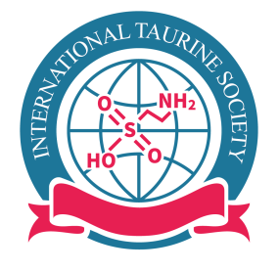 | International Taurine Society (ITS)  (Since 2016 )  - President: Stephen Schaffer (USA)  - Vice President: Abdeslem El Idrissi (USA)  - Secretary General: Ole Hartvig Mortensen (Denmark)  - Treasurer: Shigeru Murakami (Japan)  - www.taurinesociety.org

MEMBERSHIP FORM for ITS

NAME: ………………………………………………………………………………………

AFFILIATION: ………………………………………………………………………………

……………………………………………………………………………………………….

…………………………………………………………..……………………………………

Address and telephone: …………………………………………………………………….

………………………………………………………………………………………………….

E-MAIL ADDRESS: …………………………………………………………………………

TAURINE RESEARCH including animal model(s) and unique technique(s) employed:

………………………………………………………………………………………………..

………………..………………………………………………………………………………

……………………………………………………………………………………………….

……………………………………………………………………………………………….

……………………………………………………………………………………………….

OTHER RESEARCH INTERESTS: …………………………………………………………

………………………………………………………………………………………………..

………………………………………………………………………………………………..

Interest in participating committees: ……………………………………………………

Membership fee: Regular: $100.00/year ($200/2 years) or
Student: $25/year ($50/2 years)
Special donation for ITS:
Please send this form with membership fee as followings
1. Website using Pay Pal
2. Sending a check (payable to ITS in US). Our address is as follows:

International Taurine Society
Department of Pharmacology
University of South Alabama
307 University Blvd. N
Mobile, AL 36688

